Step-by-Step Implementation (With Screenshots)

Step 1: Log in to Jenkins
- Open the Jenkins UI from the top navigation bar.
- Log in using the administrator credentials.
- Verify successful access to the Jenkins dashboard.


Step 2: Install Required Jenkins Plugin
- Navigate to Manage Jenkins → Plugins → Available plugins.
- Search for Publish Over SSH.
- Select the plugin and click Install.
- Restart Jenkins after installation is completed.
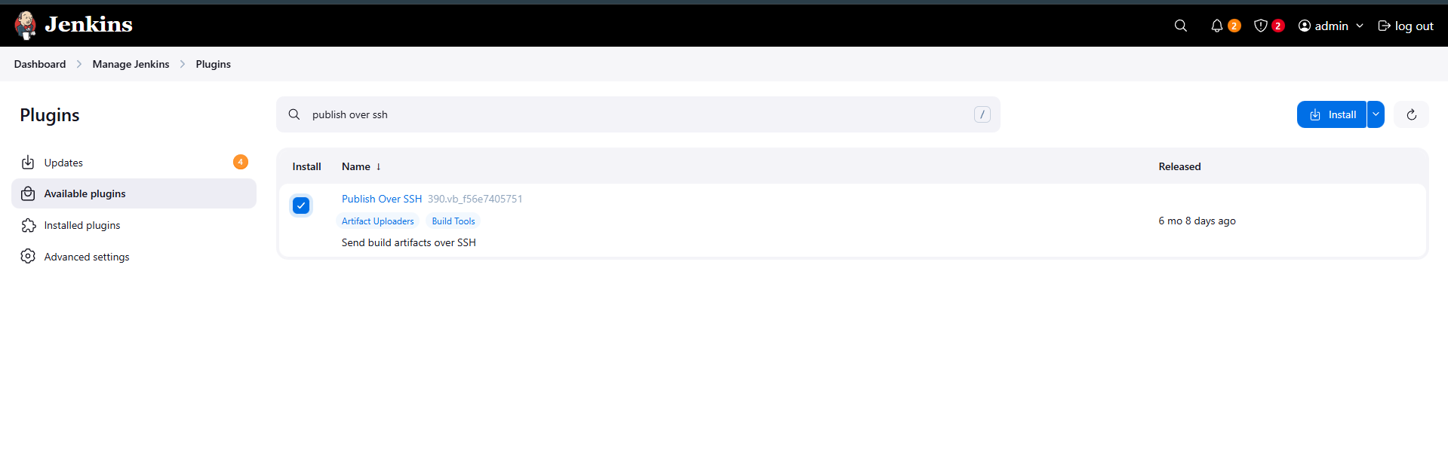
Purpose:
This plugin enables Jenkins to connect to remote servers and execute deployment and service commands.

Step 3: Configure SSH Servers in Jenkins
- Navigate to Manage Jenkins → System.
- Scroll to the SSH Servers section.
- Add SSH server configurations for:
  - ststor01 (Storage server)
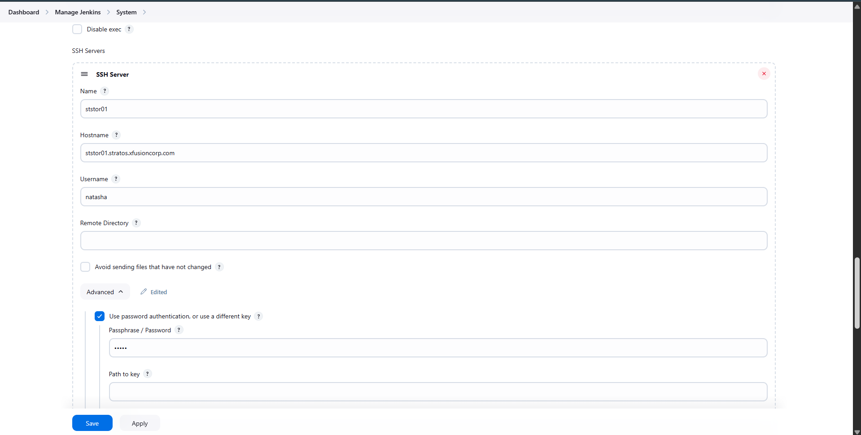
  - stapp01
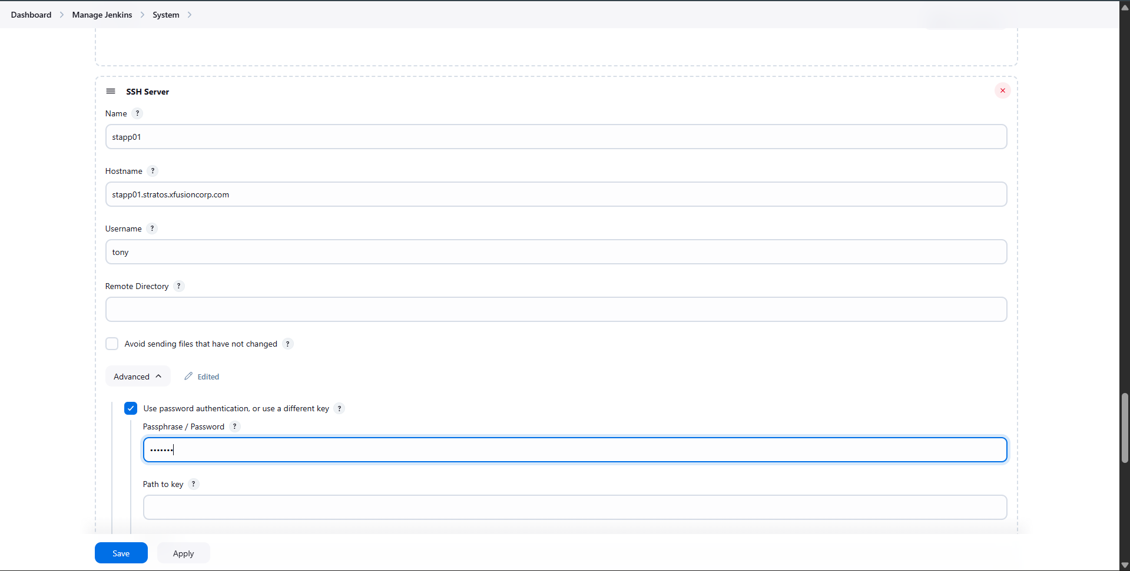
  - stapp02
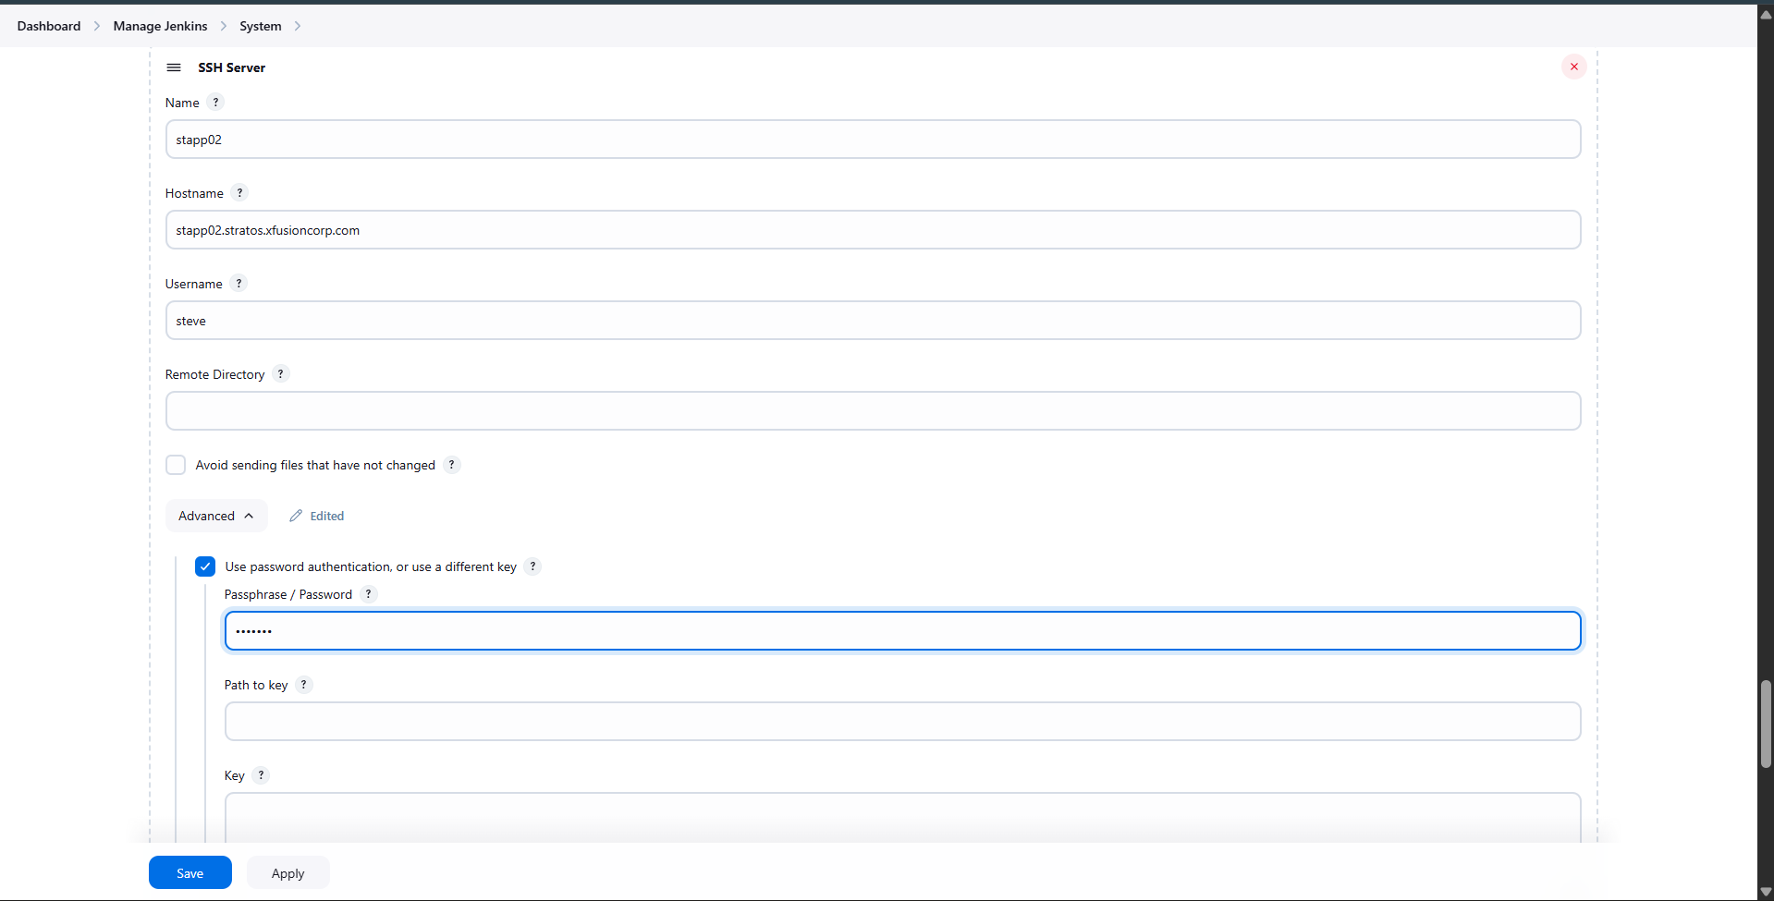
  - stapp03 (Application servers)
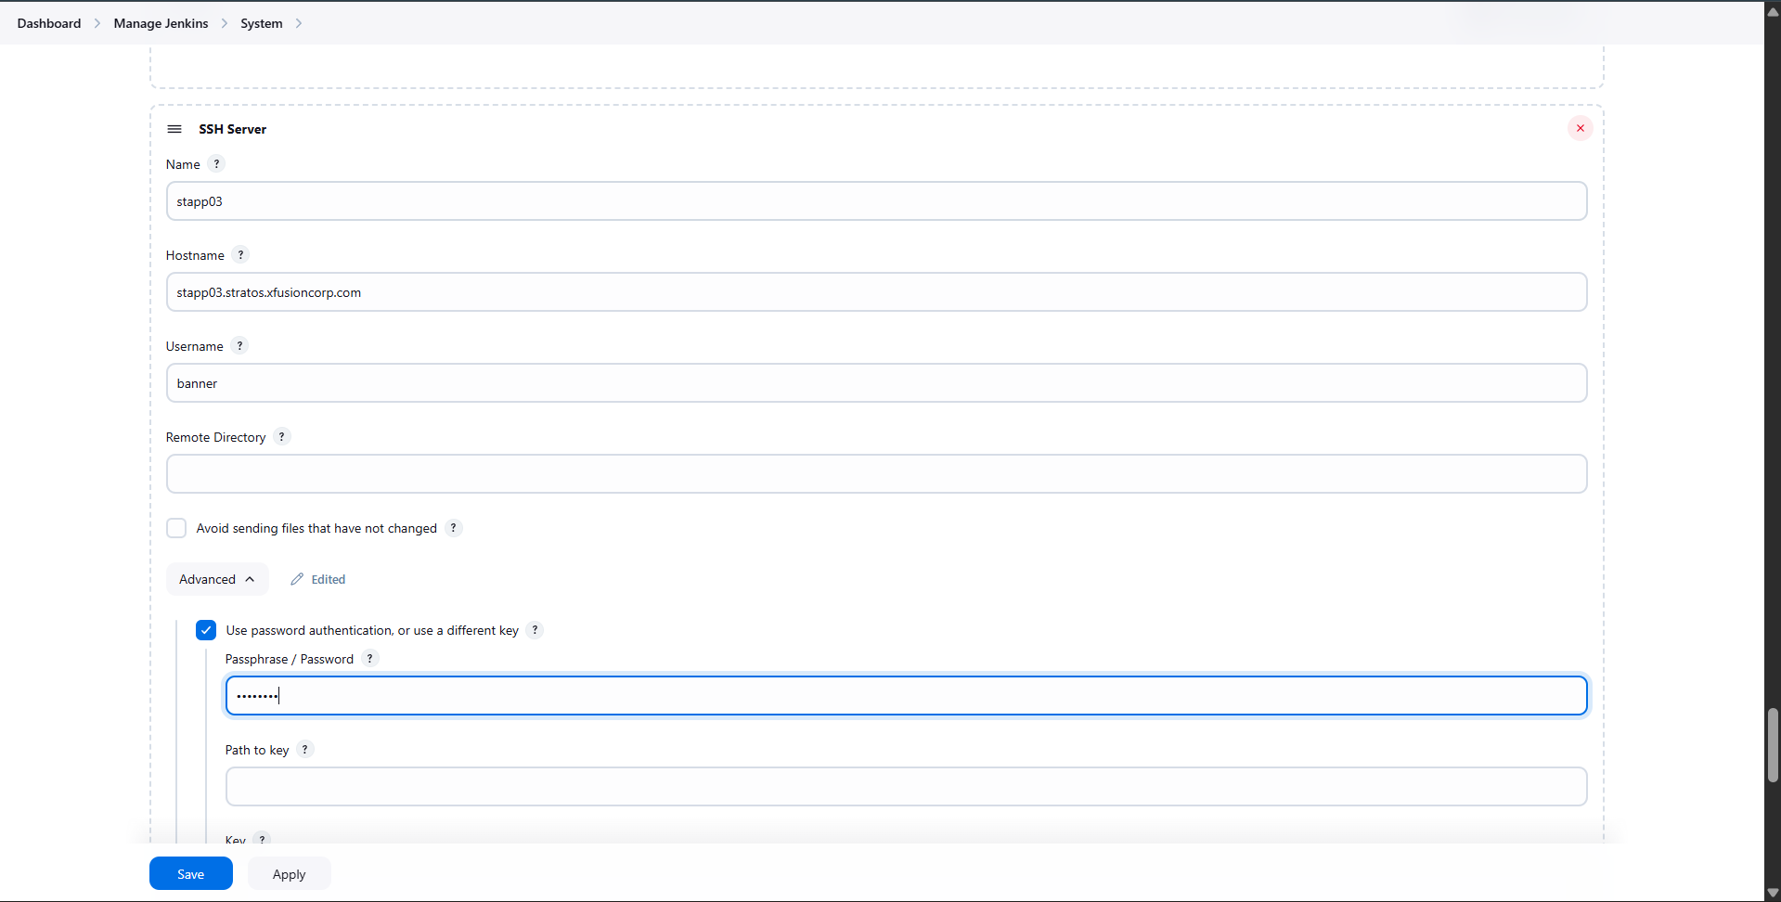
- Provide hostname, username, and password-based authentication.
- Test each connection and ensure it shows Success.
Screenshot: SSH server configuration and successful test

Step 4: Create Deployment Job (nautilus-app-deployment)
- Click New Item on the Jenkins dashboard.
- Enter the job name: nautilus-app-deployment.
- Select Freestyle project and click OK.
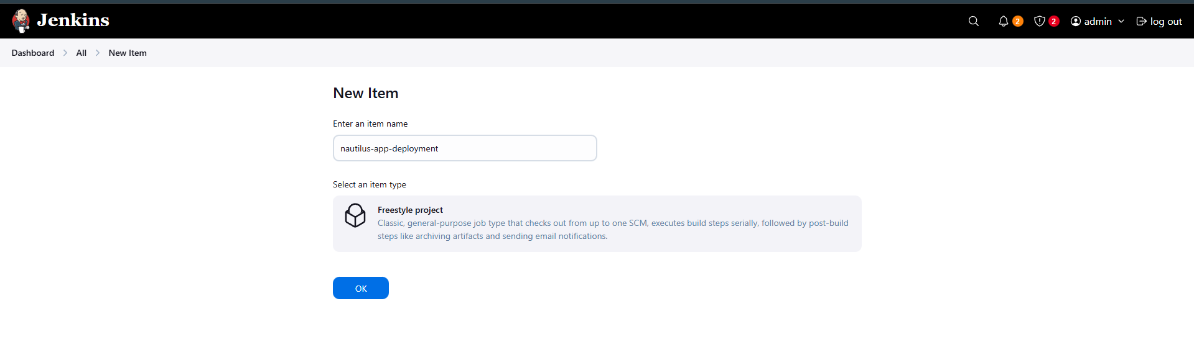

Step 5: Configure Deployment Job Build Step
- Open nautilus-app-deployment → Configure.
- Under Build Steps, add Send files or execute commands over SSH.
- Select the SSH server ststor01.
- In the Exec command field, add:
- cd /var/www/html
- git pull origin master
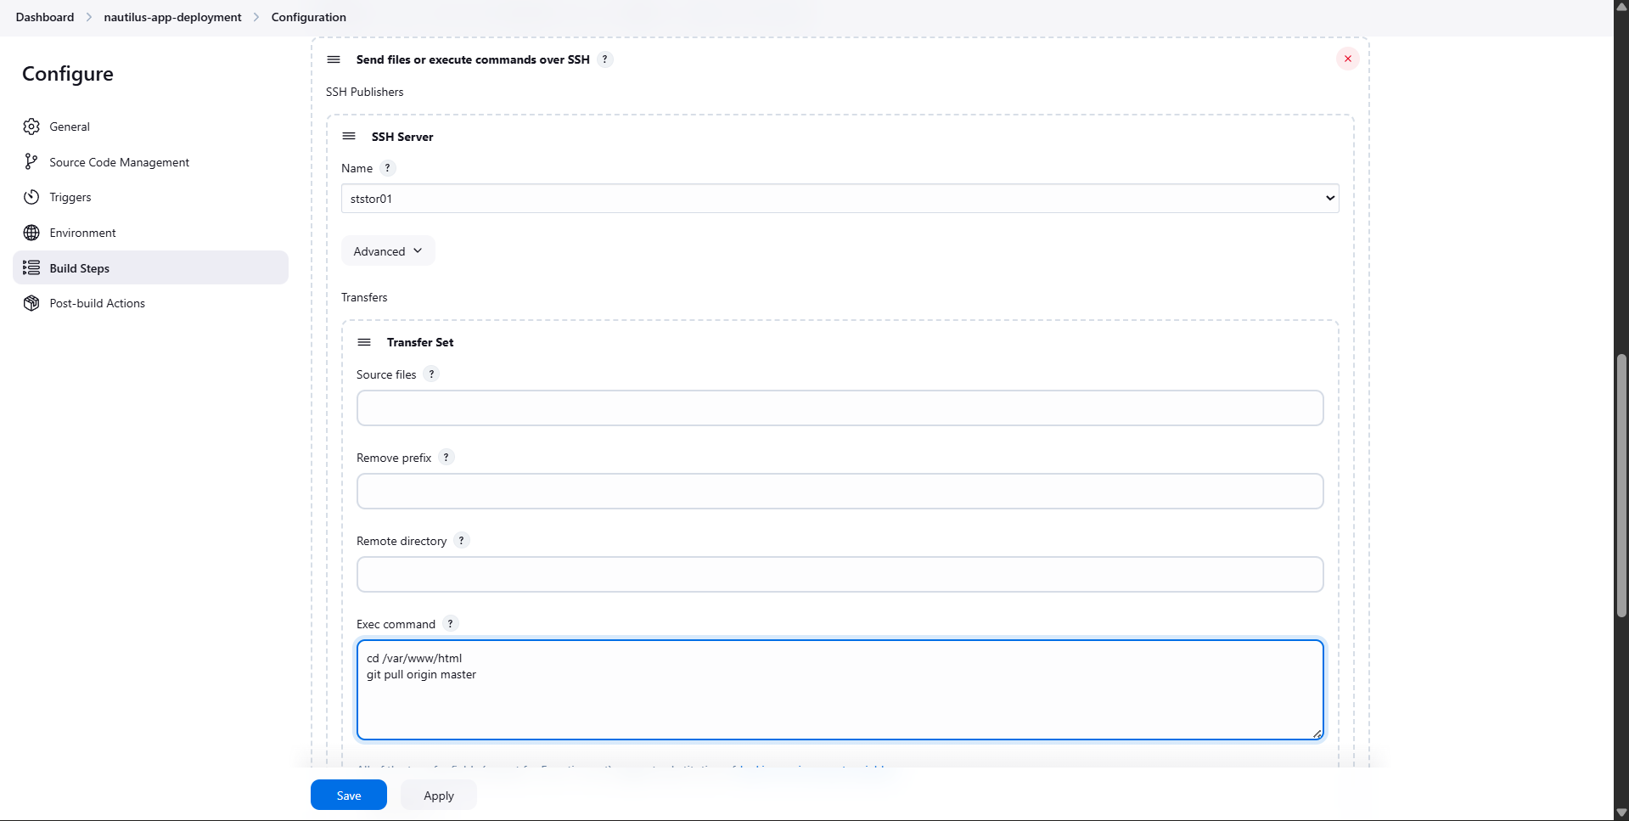
Purpose:
Pulls the latest code into the shared directory so updates reflect on all app servers.

Step 6: Configure Downstream Job Trigger
- Scroll to Post-build Actions in nautilus-app-deployment.
- Add Build other projects.
- Enter the project name: manage-services.
- Select Trigger only if build is stable.
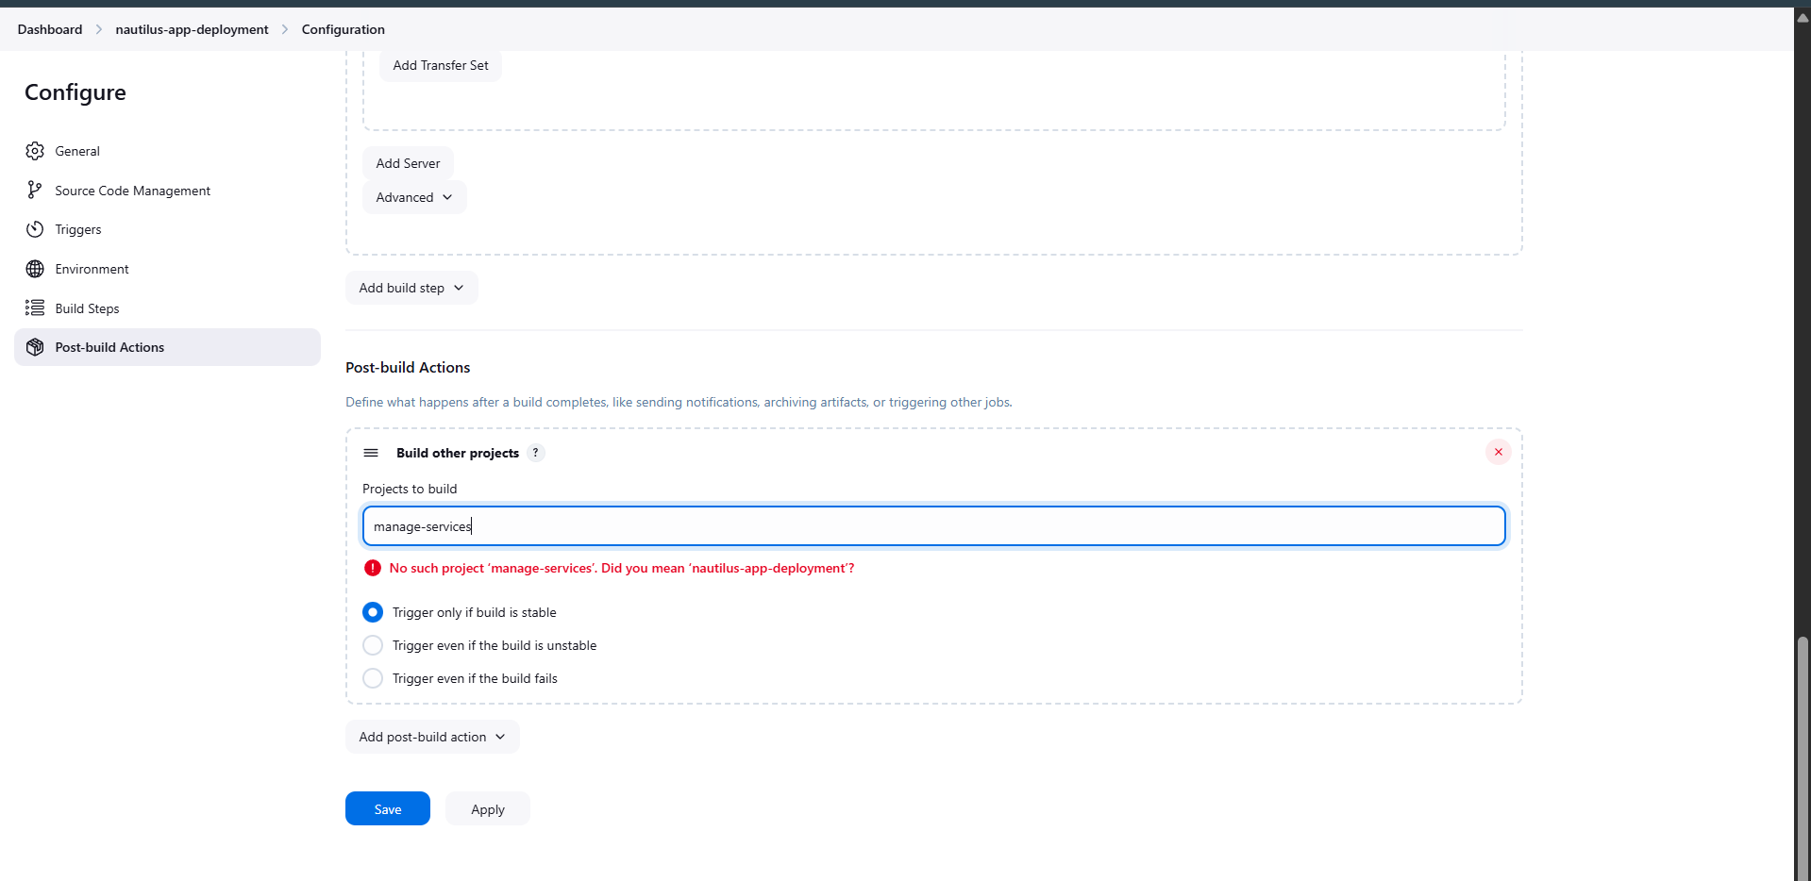

Step 7: Create Service Management Job (manage-services)
- Click New Item again.
- Enter the job name: manage-services.
- Select Freestyle project and click OK.
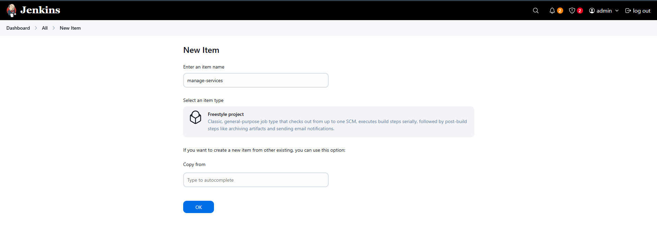

Step 8: Parameterize the Service Job
- Open manage-services → Configure.
- Enable This project is parameterised.
- Add Password Parameters:
  - STAPP01_PASS
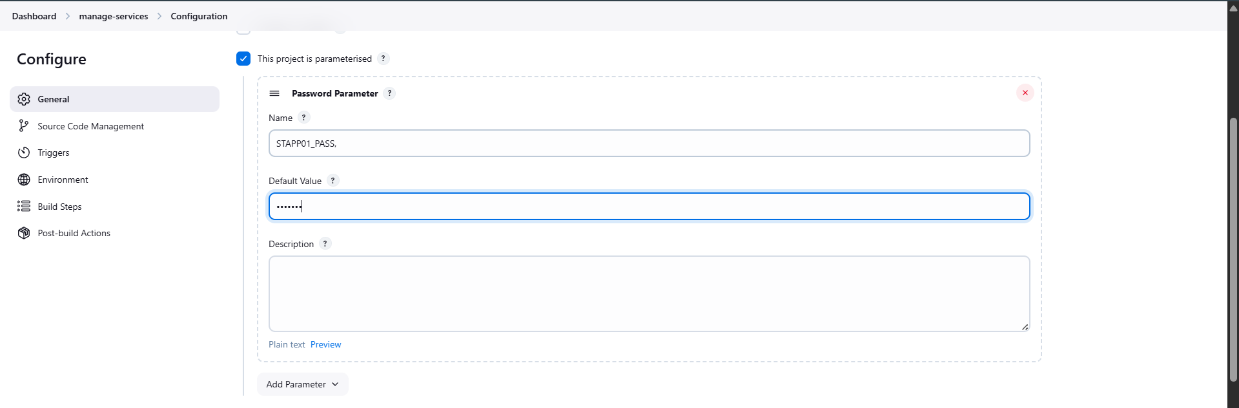
  - STAPP02_PASS
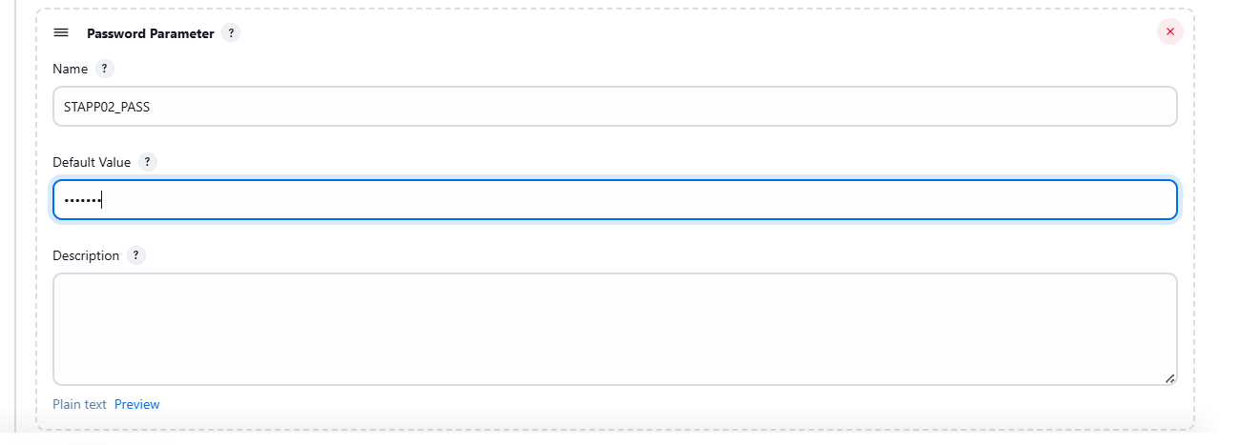
  - STAPP03_PASS
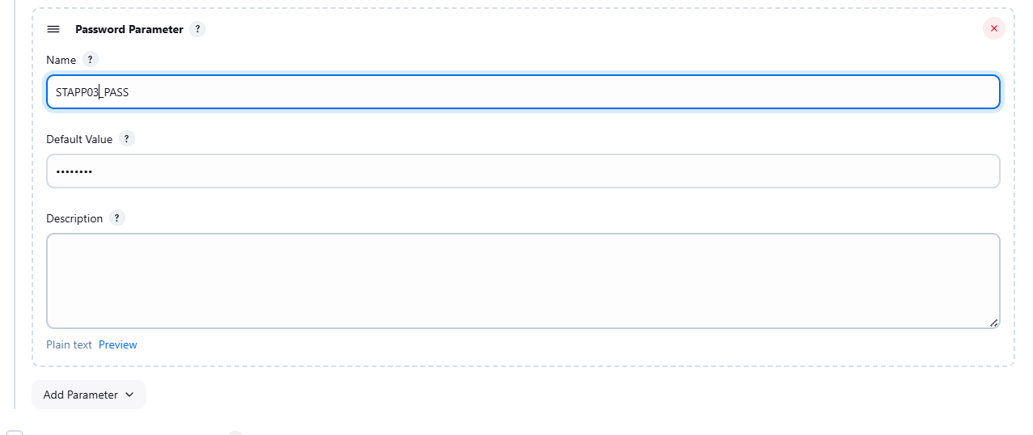
- Provide the respective sudo passwords.
Purpose:
Allows secure execution of sudo commands on application servers.

Step 9: Configure Apache Restart on App Servers
- In manage-services, add Build Steps → Send files or execute commands over SSH.
- Configure one SSH block per application server.
- Add the restart command for each server (example):
- echo "$STAPP01_PASS" | sudo -S systemctl restart httpd
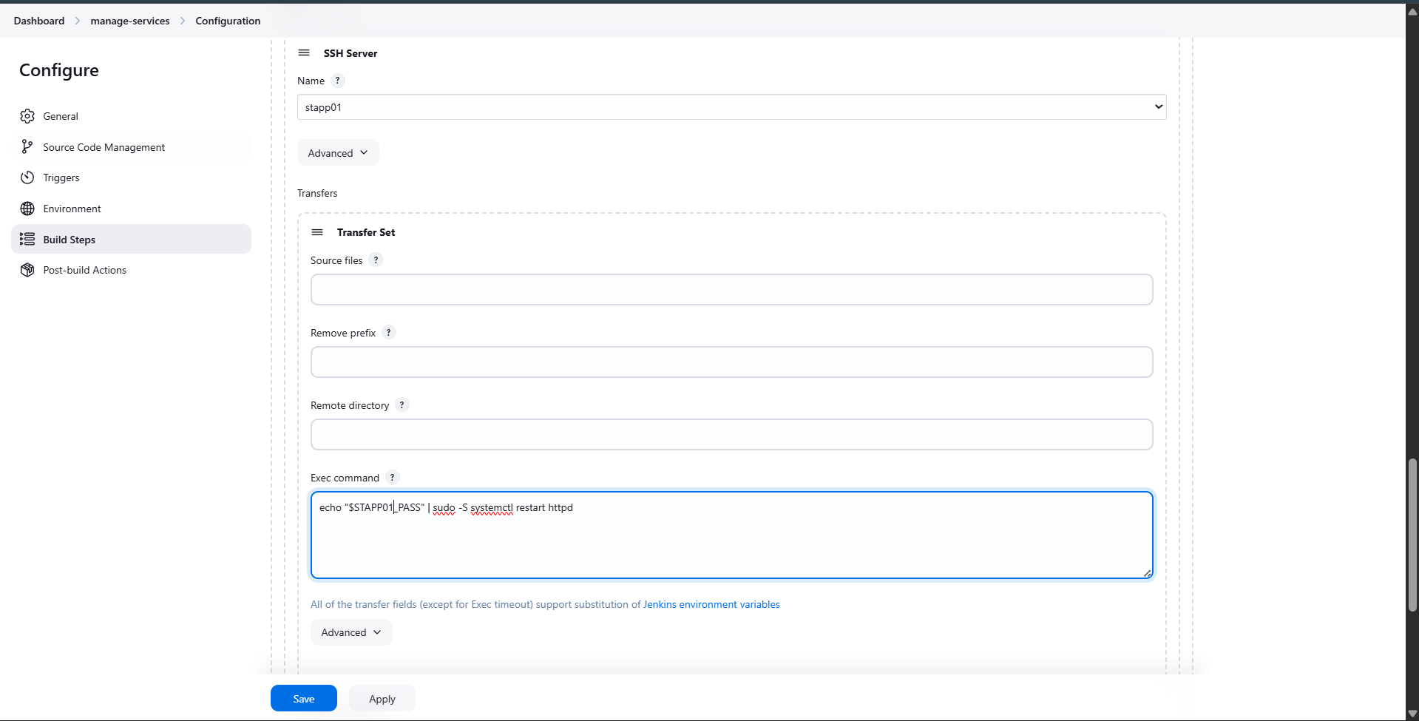
- echo "$STAPP02_PASS" | sudo -S systemctl restart httpd
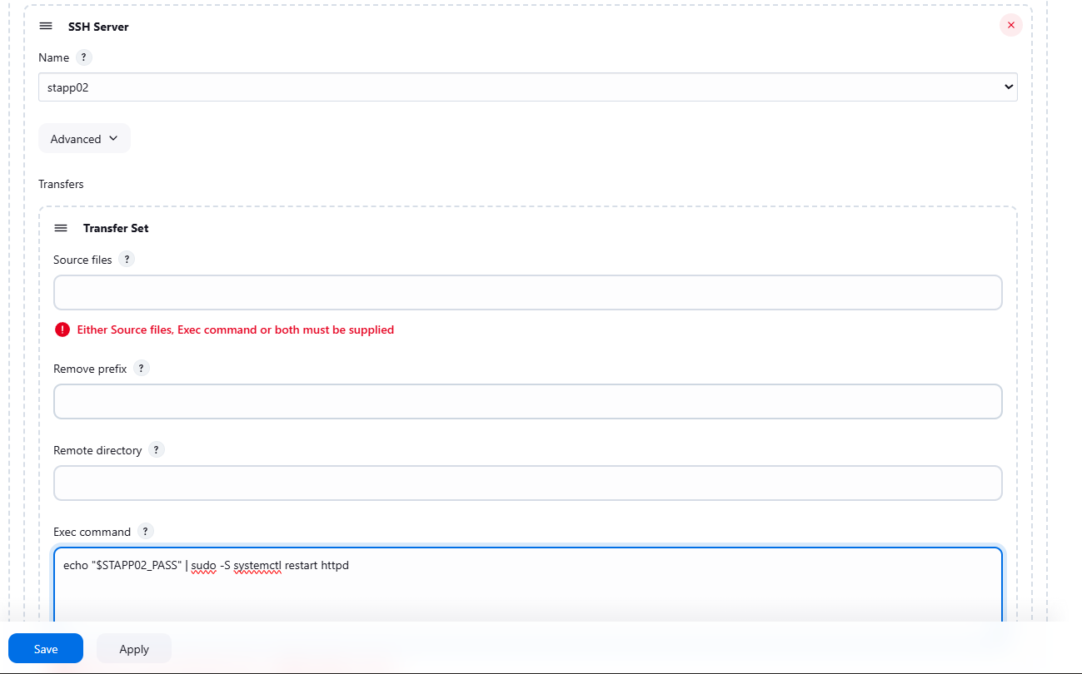
- echo "$STAPP03_PASS" | sudo -S systemctl restart httpd
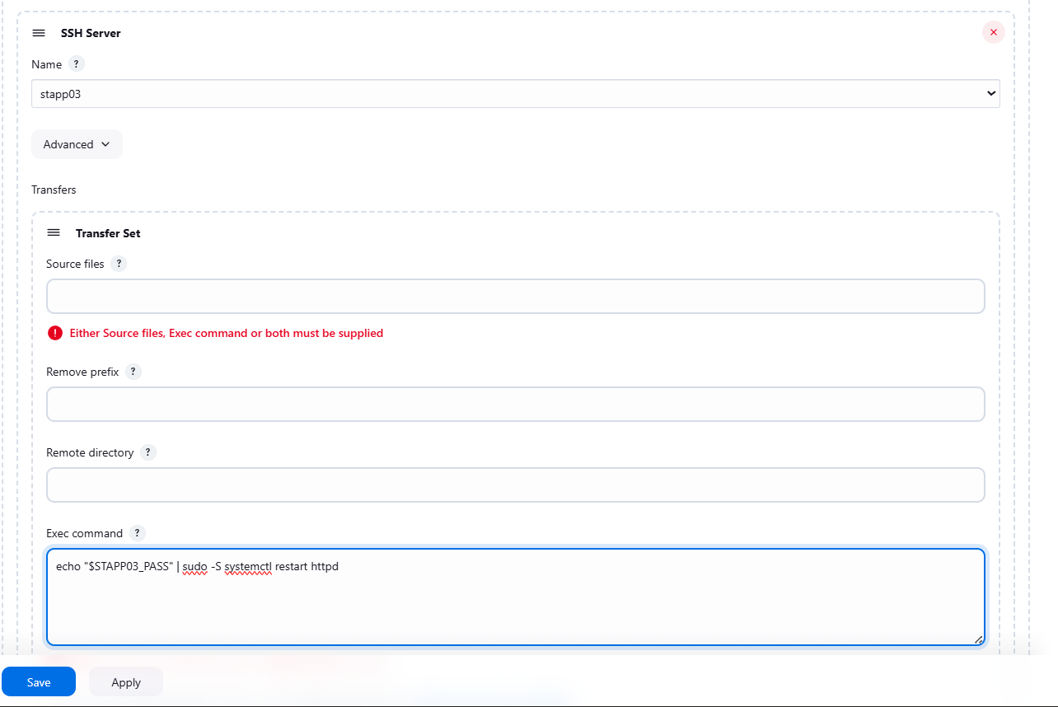

Step 10: Execute and Verify the Jobs
- Run the nautilus-app-deployment job.
- Verify the console output shows SUCCESS.
- Confirm Jenkins automatically triggers the manage-services job.
- Check that Apache restarts successfully on all application servers.
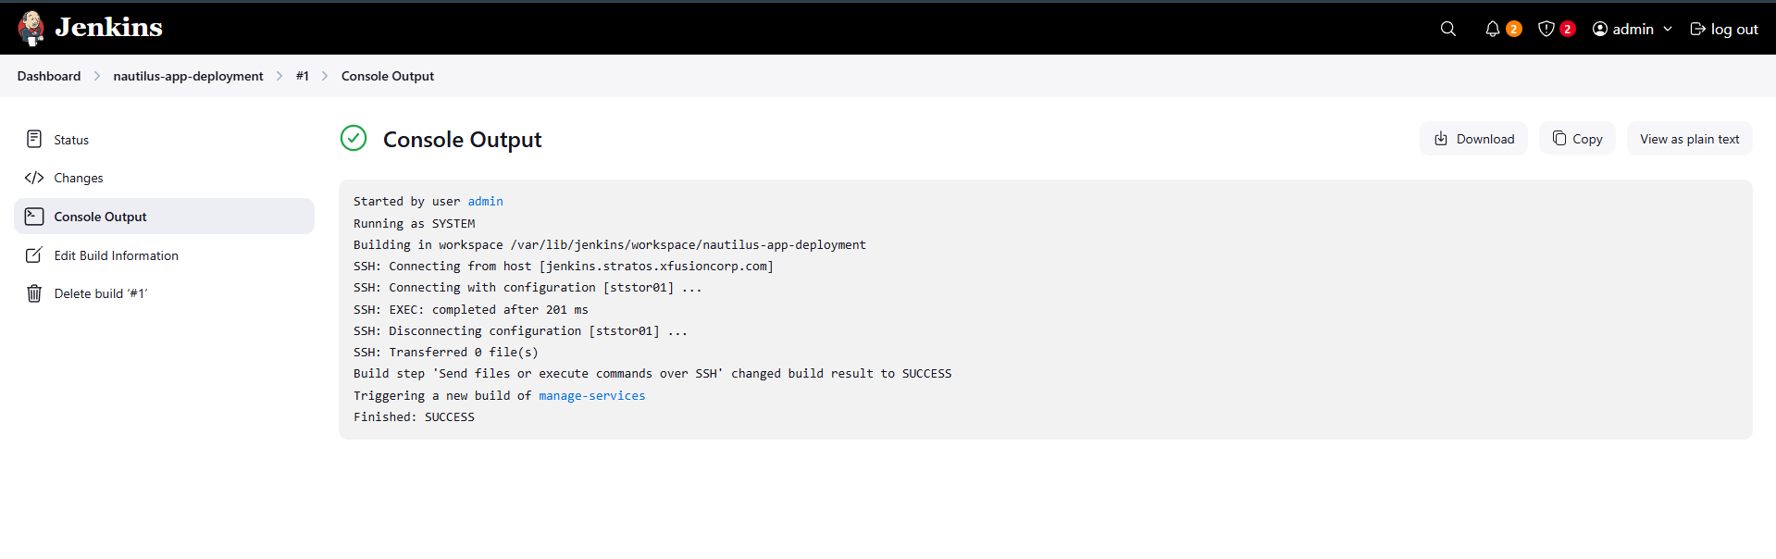
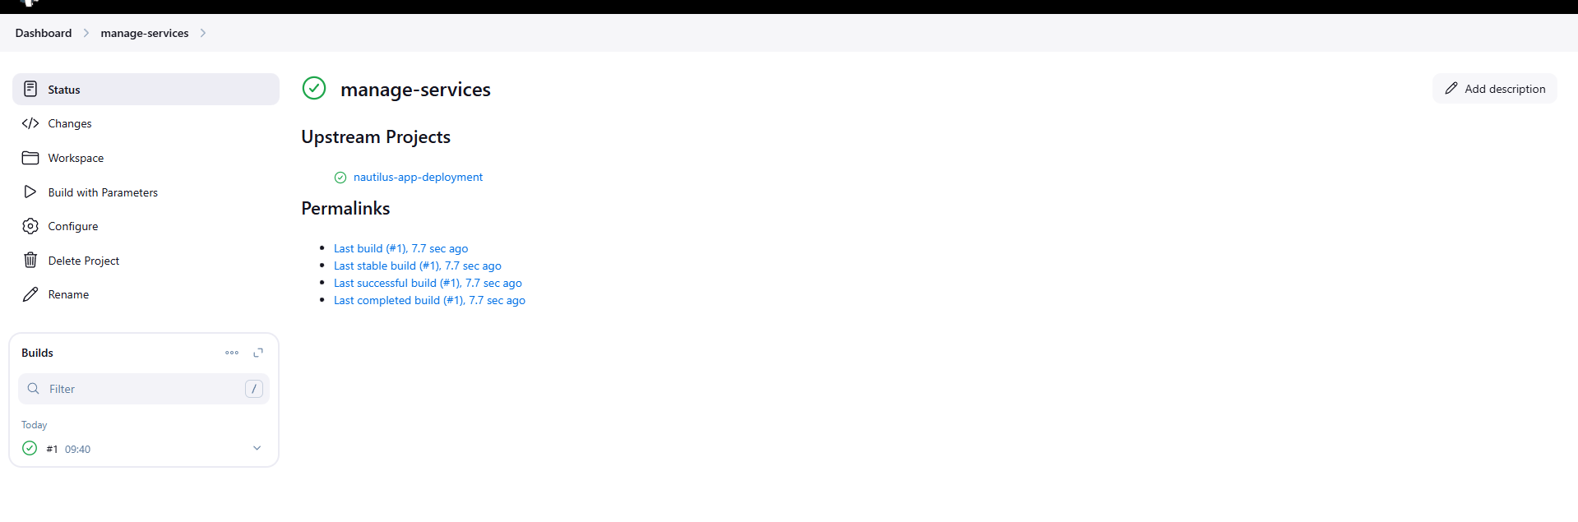

Step 11: Verify Application via Load Balancer
- Open the application using the Load Balancer URL.
- Confirm the latest content loads on the root URL (/).
- Ensure no sub-directory access is required.
